**Deploying a .NET Application in Azure**

**Create a Free Azure Trial Account**

1. Open browser and type the url: www.portal.azure.com
2. Click on Start Button under Start with an Azure free trial option

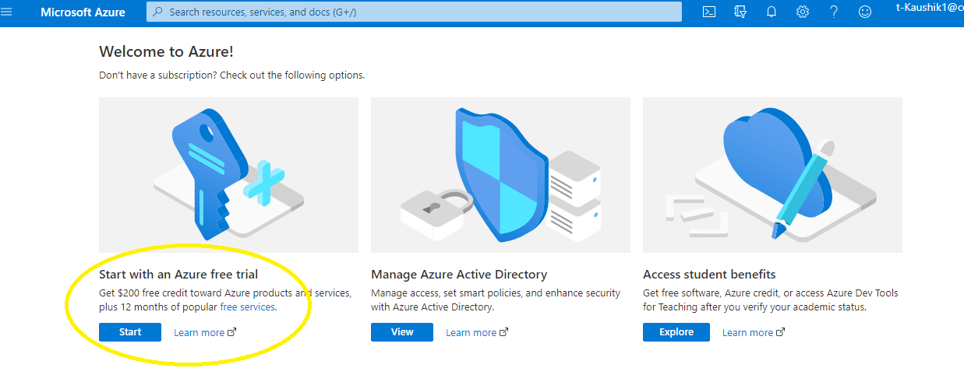

1. Login using your personal Microsoft Account / Cognizant Account (if credentials are given by organization). For personal login; if you do not have a Microsoft account, first create a free account.

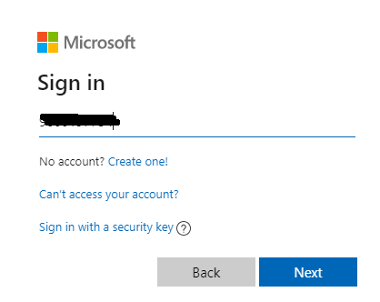

1. Now fill up the basic form in Azure and click next button

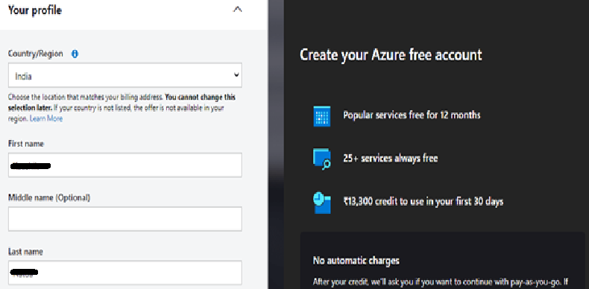

1. Verify your phone number

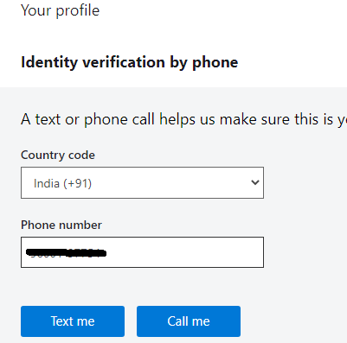

1. Now you require to provide your credit card details and click next button[But you will not be charged anything in the trial period]

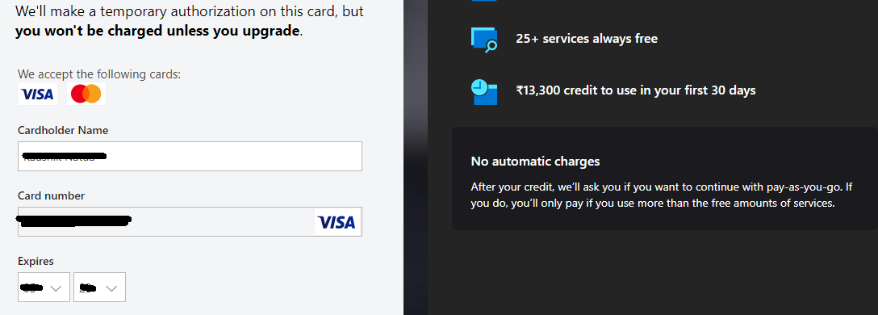

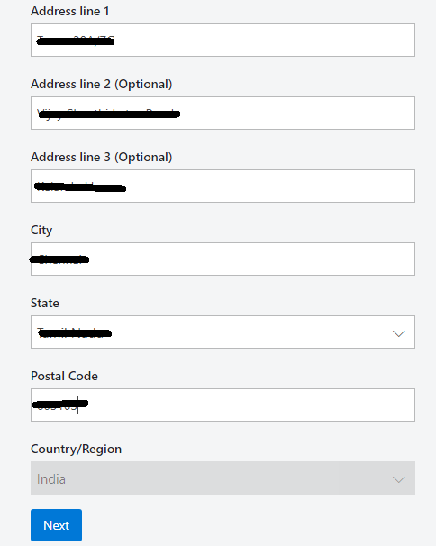

1. After you have filled up the Credit Card details and clicked Next Button, you will get an OTP and Rs. 2.00 will be deducted from your account for initial account creation

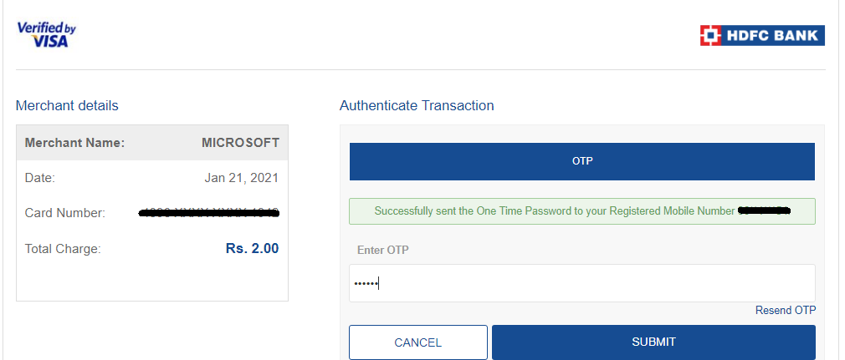

1. Once you have provided the OTP and clicked the Submit Button, you will get below screen. Click on Next Button

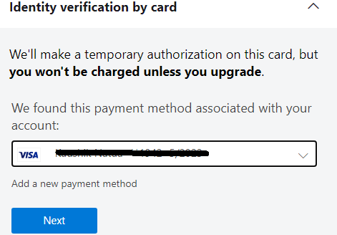

1. Now finally you will get the Submit Button to complete Azure registration.

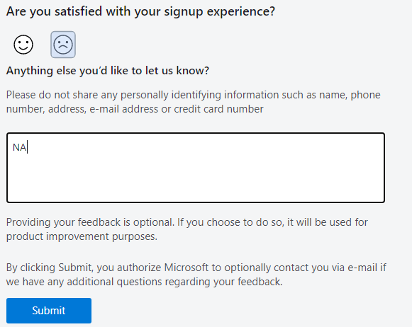

1. Now once you have clicked on Submit Button you will get access to Azure to create and deploy your applications.

**Create a ASP.NET MVC Application**

Step 1: Open Visual Studio 2019 and Select Create New Project Option

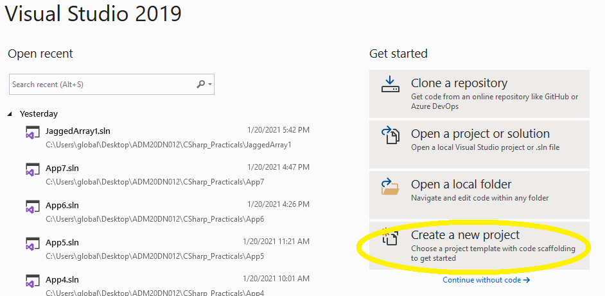

Step2: Select ASP.NET Web Application for .NET Framework

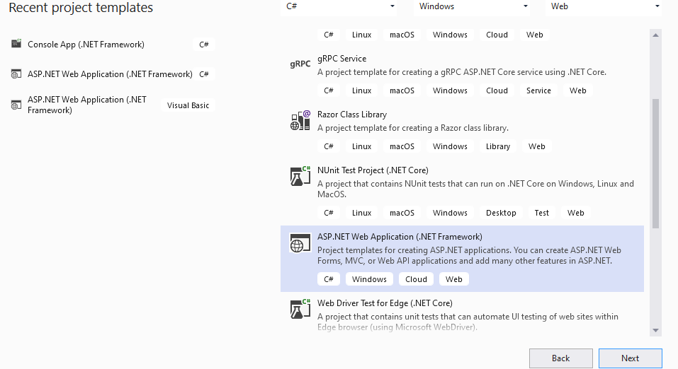

Step3: Give your Project Name and Location information and click Create Button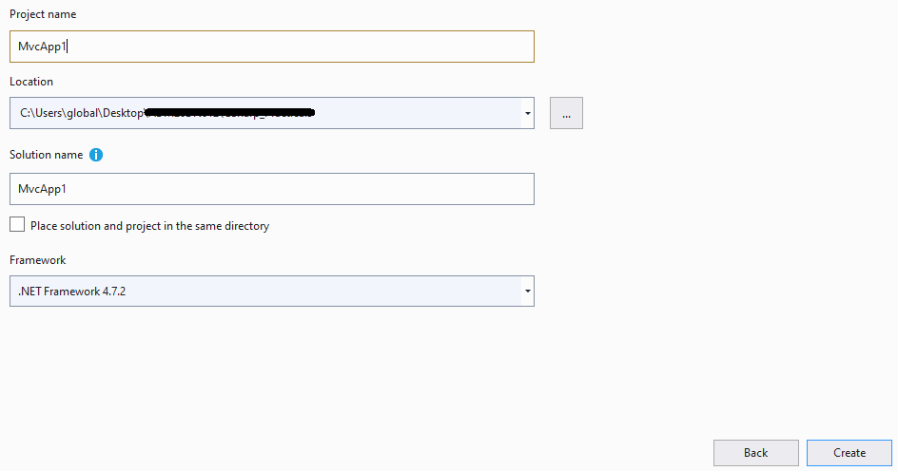

Step 4: Choose MVC Project Template and click Create button

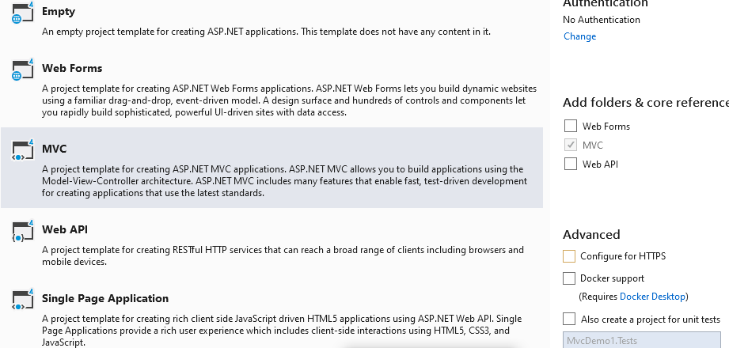

Step5: Create a model class under Models Folder called Trainee.cs

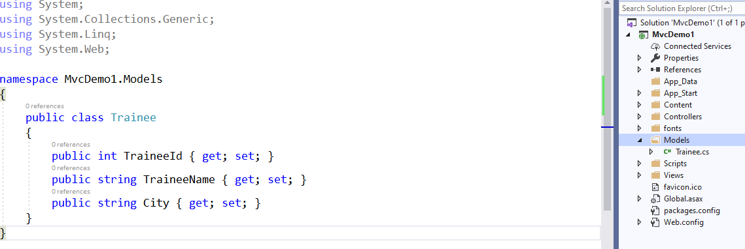

Step6: Now go to the controller and hard code a List of Trainees under Index() action. [Remove the About() and Contact() actions from controller and its corresponding views from the project as it is not required].

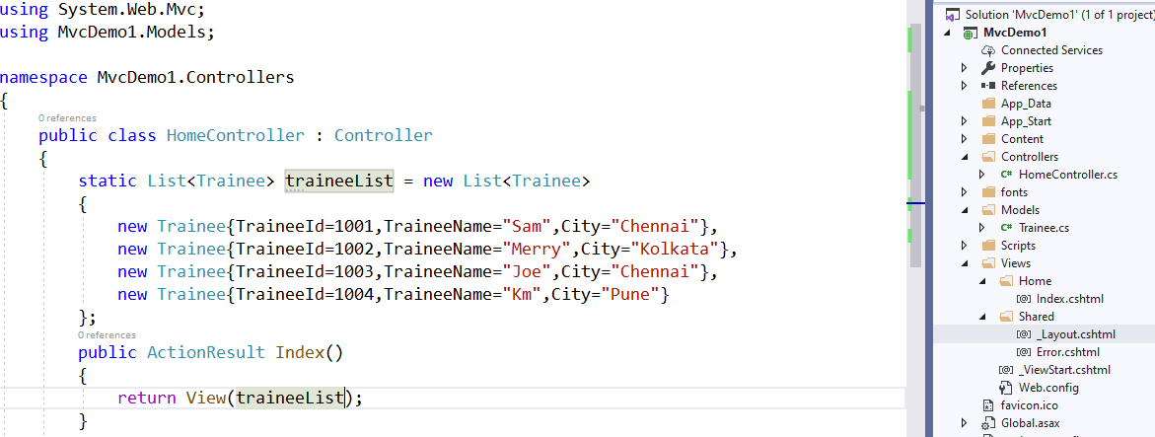

Step7: Configure the Index View using Scaffolding List Template to display Trainee Records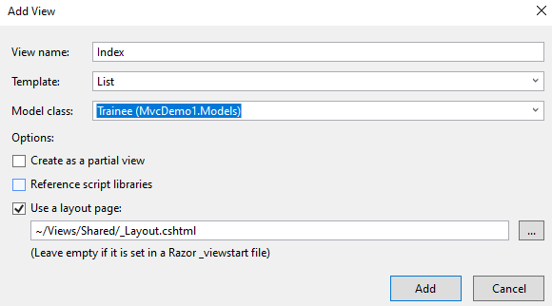

Step8: Now run the application (start without debugging)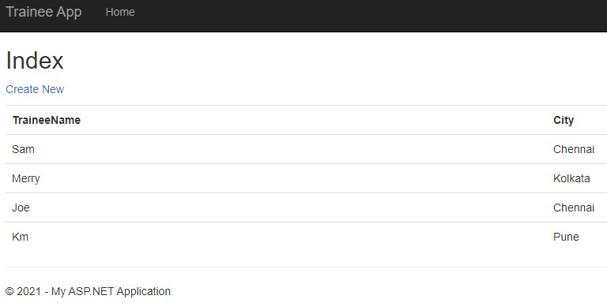

**Now to deploy your application in Azure follow the below steps:**

Step1: Select on App Services and click on create

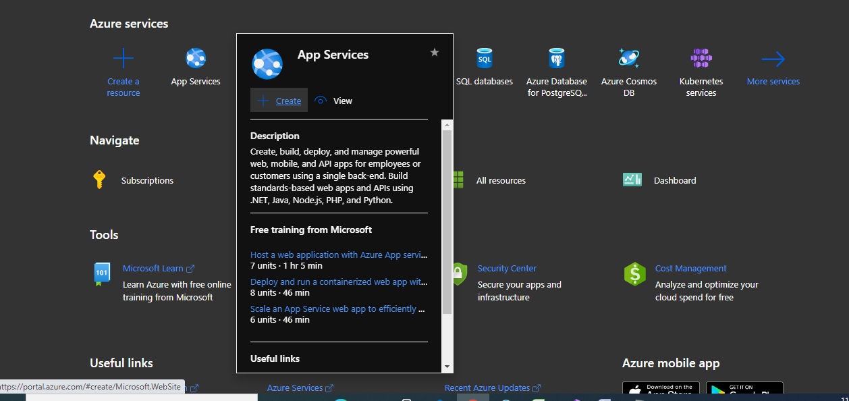

Step2: Now Create Web App in Azure by filling the below details:

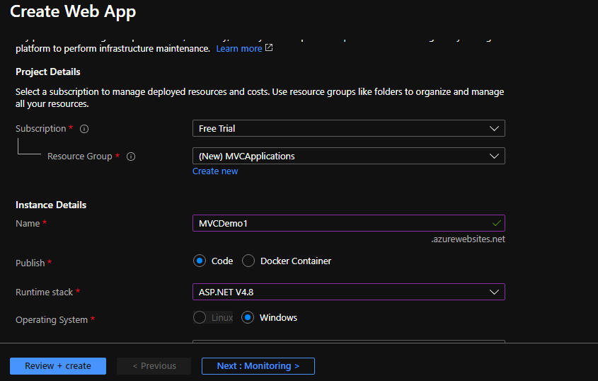

(a) Resource Name - Resource name of your app. You can add the new app to an existing Resource Group or Create New

(b) Instance Name – Web App Name

(c) Runtime Stack: Choose the version of .NET

Step 3: Now once you click on Review+Create Button you will get the below page where you have to click on Create Button

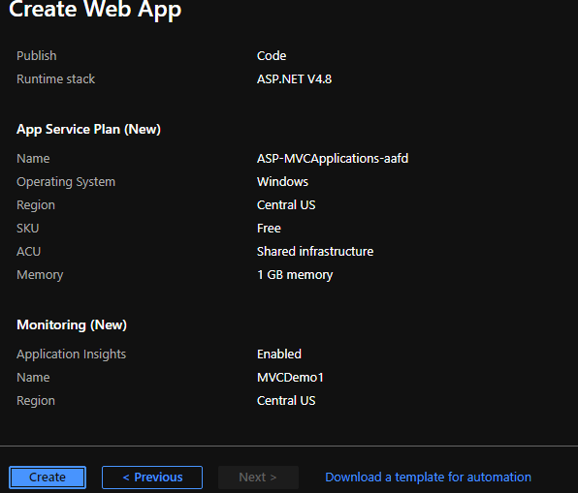

Step 4: Now under Deployment Details Click on MVCDemo1

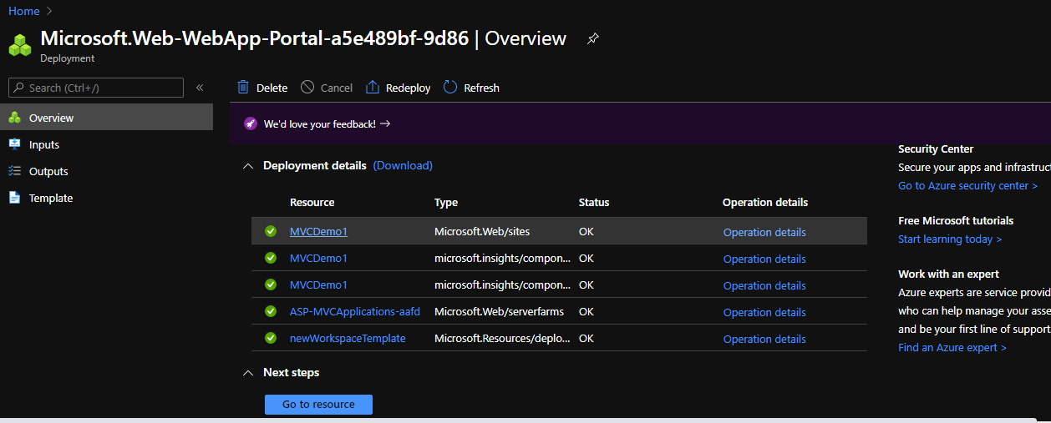

Step 5: You will get the MVCDemo1 app information which you have just now created:

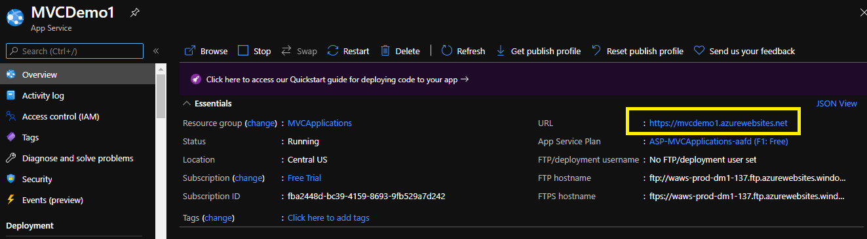

Step6: Now download the Publish Profile which you will require when you are publishing your application to Azure using Visual Studio

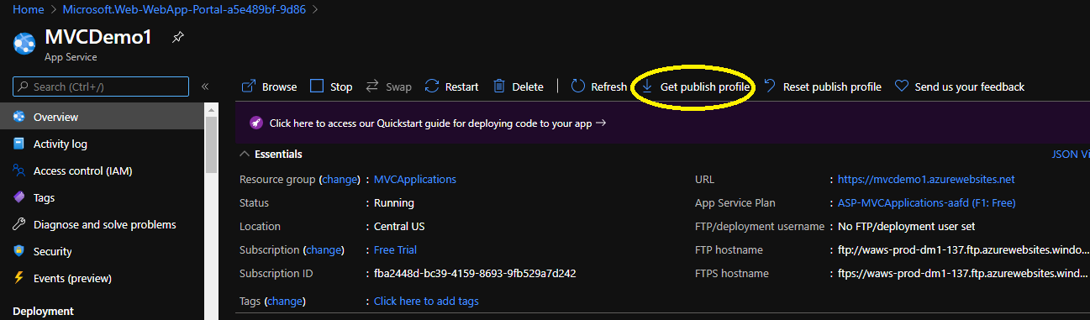

Step 7: Now go back to Visual Studio -> Your Application. Right Click on your Project and select Publish Option.

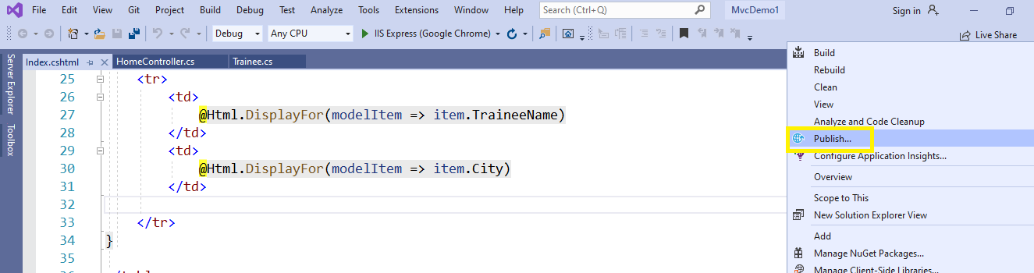

Step 8: Now Select the Import Profile Option and click Next Button

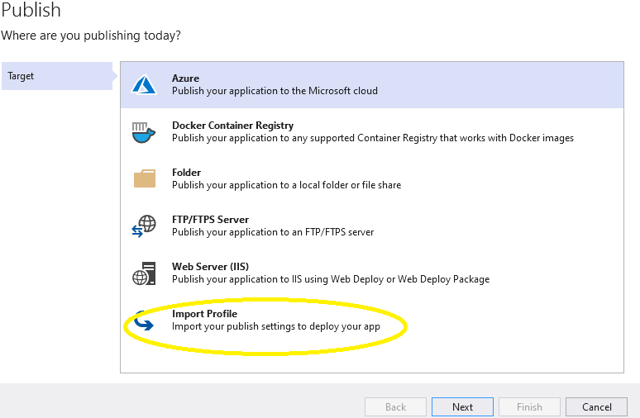

Step 9: Import the Publish Profile which you have downloaded from Azure Portal and Click Finish Button

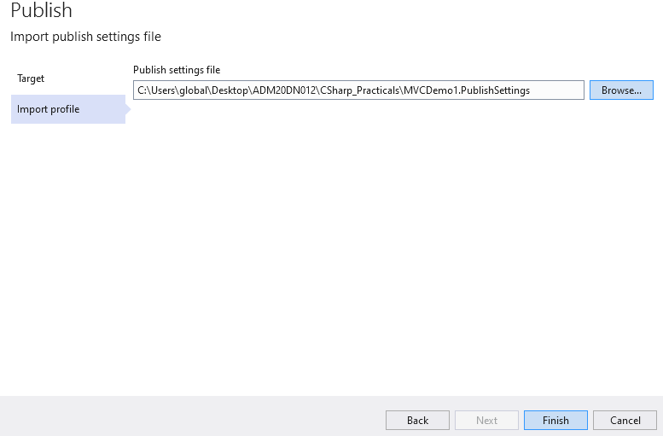

Step 10: Now Choose Web Deploy Option and Click Publish Button to publish your application in Azure.

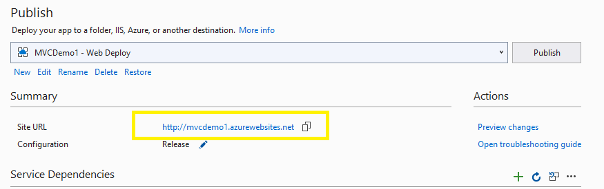

***Note: Here*** [***http://mvcdemo1.azurewebsites.net***](http://mvcdemo1.azurewebsites.net) ***is the url through which we can run the web application from anywhere once the application is published in Azure.***

Now, you will notice that Visual Studio will build the project first and then start publishing files to Azure.

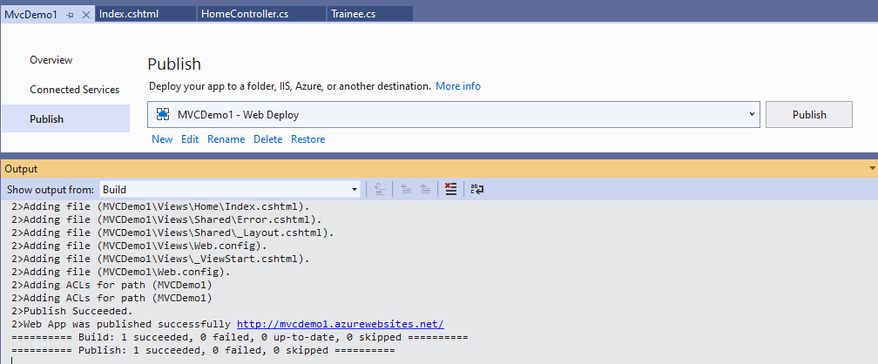

Step 11: Once publish is done run the above url in browser to check your application.

